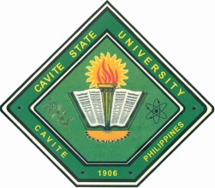Republic of the Philippines

**CAVITE STATE UNIVERSITY**

CCAT Campus

Rosario, Cavite

🕾 *(046) 437-9505 /* 🖷 *(046) 437-6659*

cvsu.rosario@gmail.com

www.cvsu-rosario.edu.ph

**(DEPARTMENT)**

**Trainee :**

**Title : A NARRATIVE REPORT: TRAINING EXPERIENCES AT**

**APPROVED:**

_____  **REGIE C. DELOS REYES** _____

Area Coordinator Date OJT Coordinator Date

_____ **MARILOU P. LUSECO** _____

Department Chairperson Date Director, Instructions Date

**JOSE P. LISAMA, EdD** _____

Campus Administrator Date